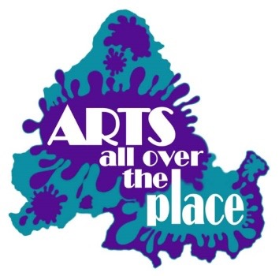
Membership form Arts All Over The Place Registered charity Number 1178638
Our charitable purpose is: The relief of those in need, in particular people with mental and emotional health and wellbeing needs, through the use of the arts.
Name please print clearly

Best way of contacting you: ( e mail is our preferred way)

Please include your mobile number if you have one.

please print clearly

Who should we contact about you in an emergency? (A name and a mobile number for that person please, and please ensure we have their permission to hold those details))

Have you ever personally experienced mental ill-health? Yes No

Do you care for someone with mental health problems? Yes No

Have you used any service eg NHS, Mind, Support services?
.
Please write the name of the service you used
please print clearly

How can Arts All Over The Place help you?

We have a range of leaflets etc showing details of services locally, and can signpost you to ones that may be suitable to help you if needed, just ask someone on duty today.

We have Data protection policies in place and will never pass on personal details without your permission.

Signature…………………………………………………………………………………………………………………………………..

Date Joined

Please tick this box if you consent to us holding your data.
We hold your data for the sole purpose of letting you know about future events.

